# Lab4 - WAP for using Input, Output and fail predicates in prolog.

Write program using write, writef, readint,readchar,readln ,readreal predicates

• Store facts of employee name, age, job location, marital status and gender.

Display (i) list of married & unmarried employees

(ii) List of male & female employees

(iii) List of employees for given job location

**Code:**

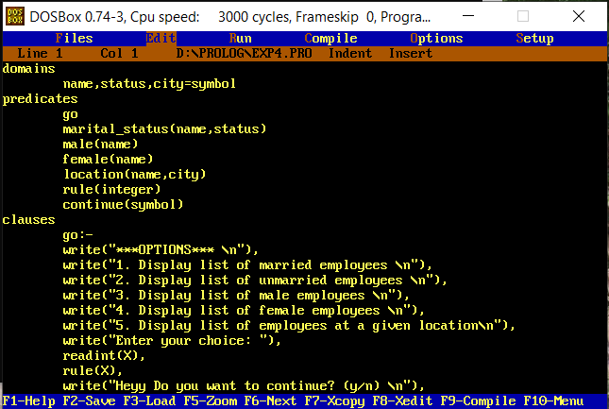

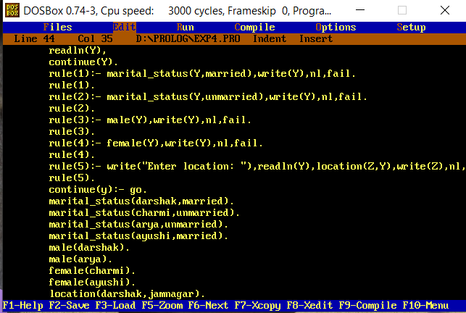

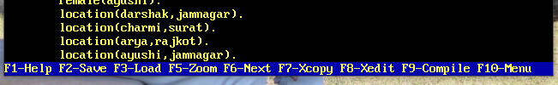

**Output:**

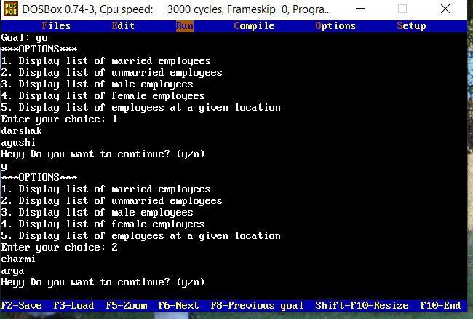

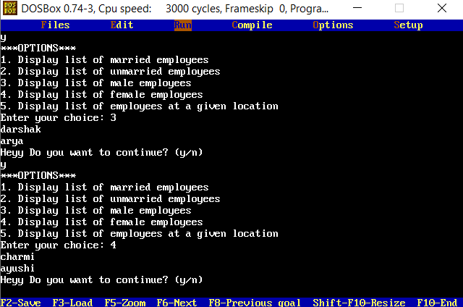

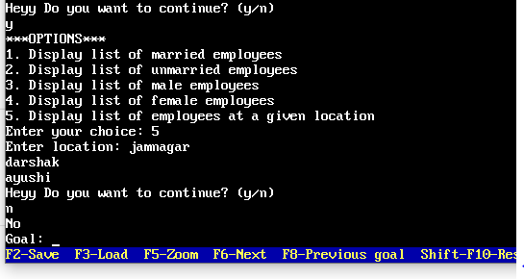

**Code:**

**domains**

**name,status,city=symbol**

**predicates**

**go**

**marital_status(name,status)**

**male(name)**

**female(name)**

**location(name,city)**

**rule(integer)**

**continue(symbol)**

**clauses**

**go:-**

**write("***OPTIONS*** \n"),**

**write("1. Display list of married employees \n"),**

**write("2. Display list of unmarried employees \n"),**

**write("3. Display list of male employees \n"),**

**write("4. Display list of female employees \n"),**

**write("5. Display list of employees at a given location\n"),**

**write("Enter your choice: "),**

**readint(X),**

**rule(X),**

**write("Heyy Do you want to continue? (y/n) \n"),**

**readln(Y),**

**continue(Y).**

**rule(1):- marital_status(Y,married),write(Y),nl,fail.**

**rule(1).**

**rule(2):- marital_status(Y,unmarried),write(Y),nl,fail.**

**rule(2).**

**rule(3):- male(Y),write(Y),nl,fail.**

**rule(3).**

**rule(4):- female(Y),write(Y),nl,fail.**

**rule(4).**

**rule(5):- write("Enter location: "),readln(Y),location(Z,Y),write(Z),nl,fail.**

**rule(5).**

**continue(y):- go.**

**marital_status(darshak,married).**

**marital_status(charmi,unmarried).**

**marital_status(arya,unmarried).**

**marital_status(ayushi,married).**

**male(darshak).**

**male(arya).**

**female(charmi).**

**female(ayushi).**

**location(darshak,jamnagar).**

**location(charmi,surat).**

**location(arya,rajkot).**

**location(ayushi,jamnagar).**